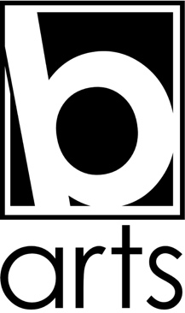

“All Aboard The Knotty”
Easy Read Visual Story

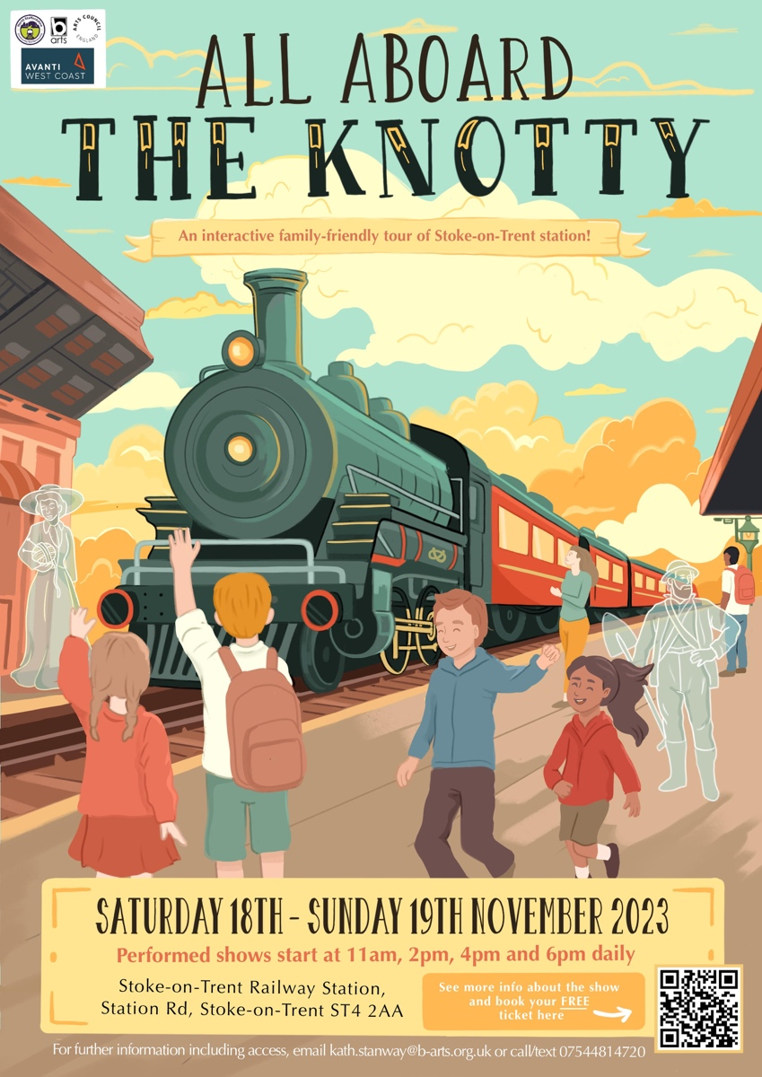

About the Performance

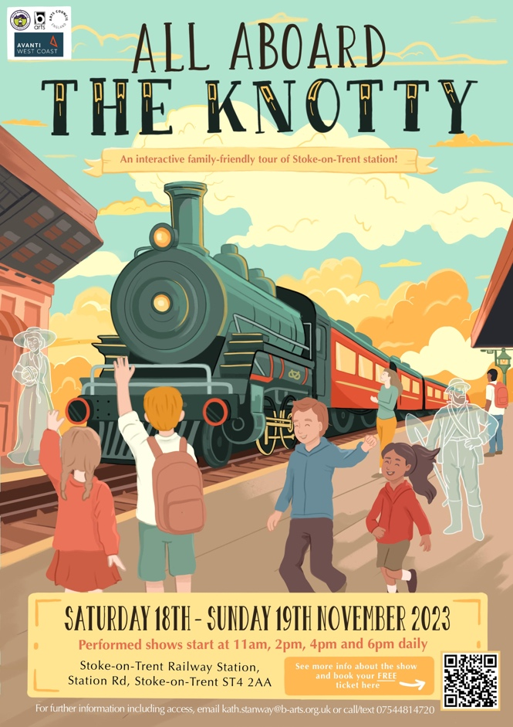 | “All Aboard The Knotty” is a show by B arts.  The show takes place in the form of a tour.
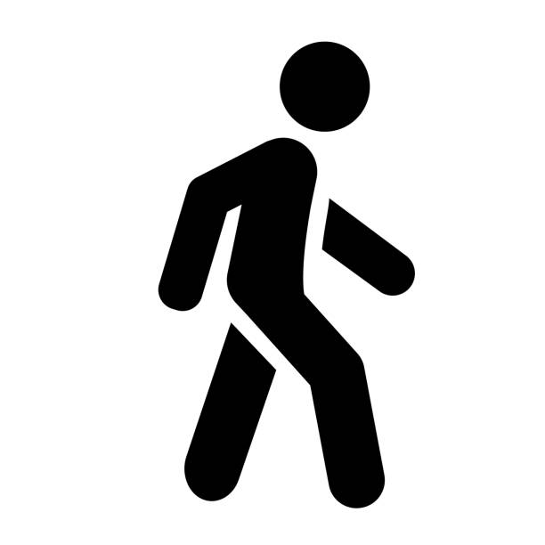 | We will be walking around altogether throughout the show
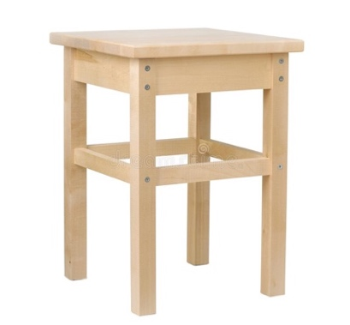 | There will be some seats in each section if you need to sit down.
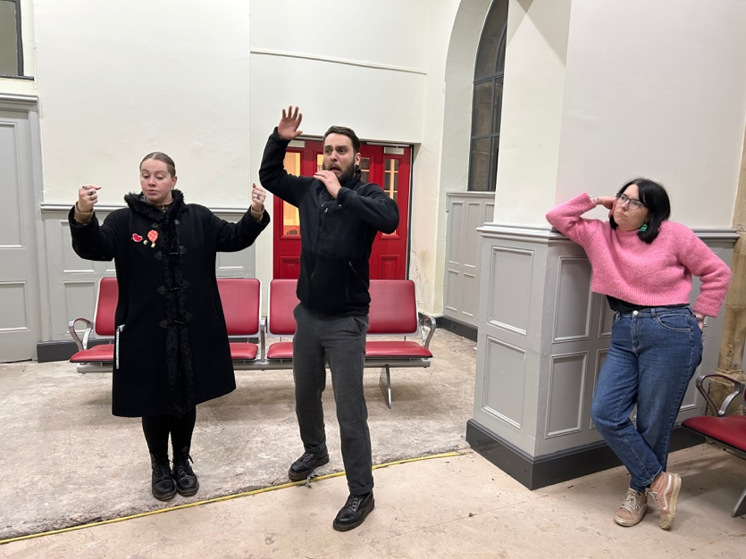 | 7 performers perform in the show “All Aboard The Knotty’
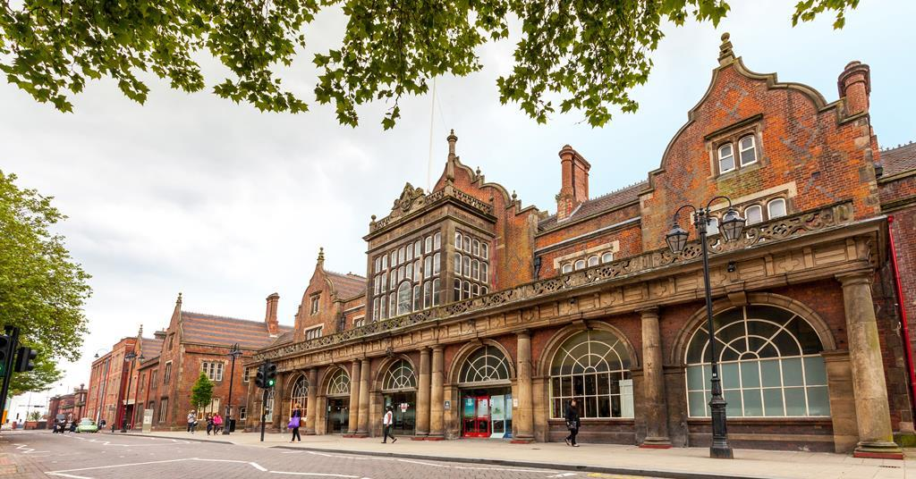 | The show is performed at Stoke on Trent Railway Station
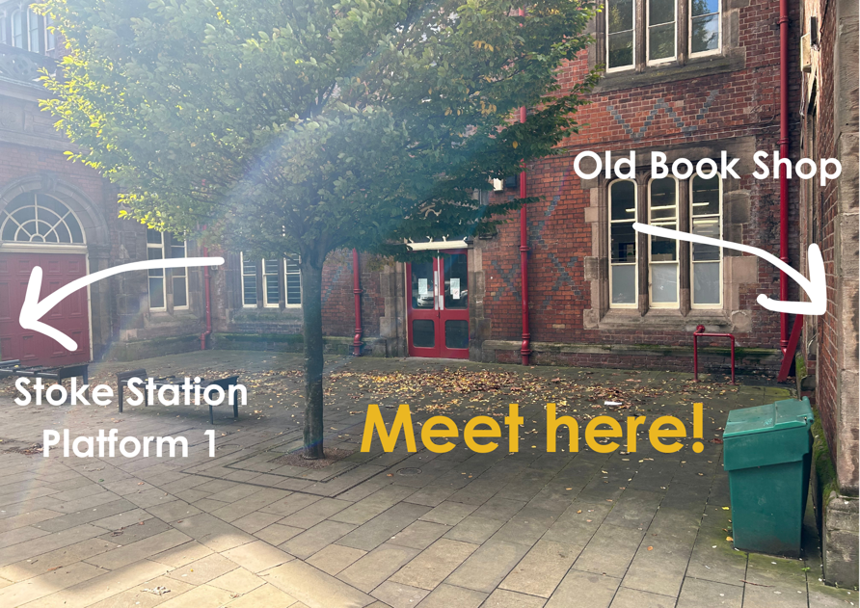 | This is the meeting point you will use when coming to watch the show “All aboard The Knotty” at Stoke on Trent Railway Station.
 | Outside the Train Statio may be a little bit noisy
 | There is an accessible toilet on platform 1 and platform 2.
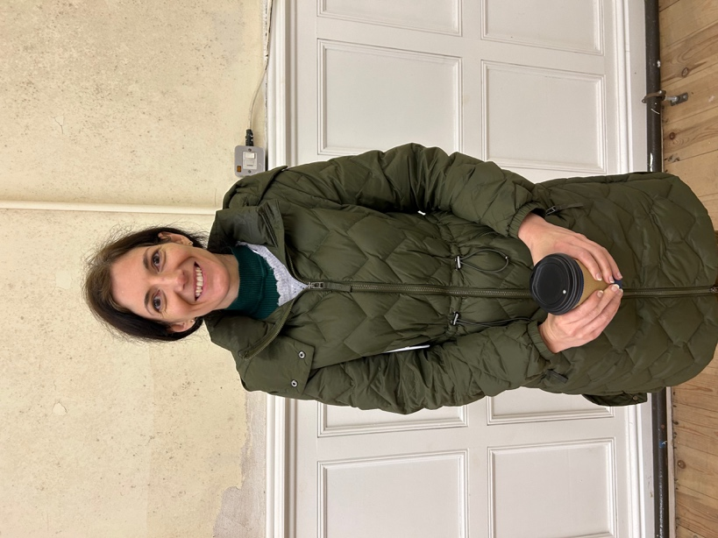 | This is Rebecca.  You can ask her for any assistance
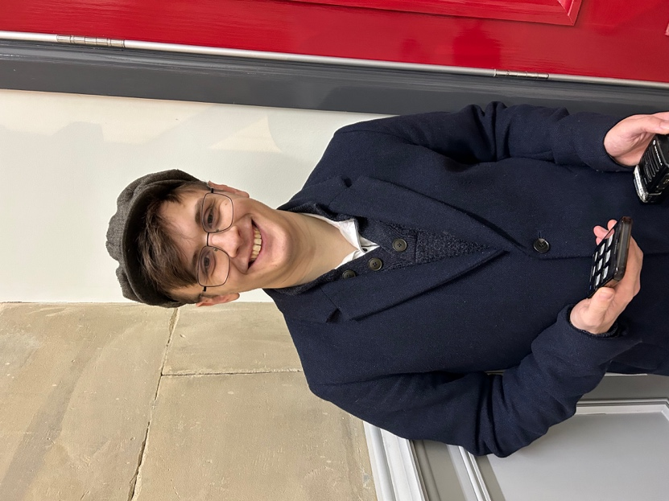 | This is Ewan  He will be there to welcome you  You can ask him for any assistance
 | “All Aboard The Knotty” is an inclusive show. It is a relaxed and accessible show.
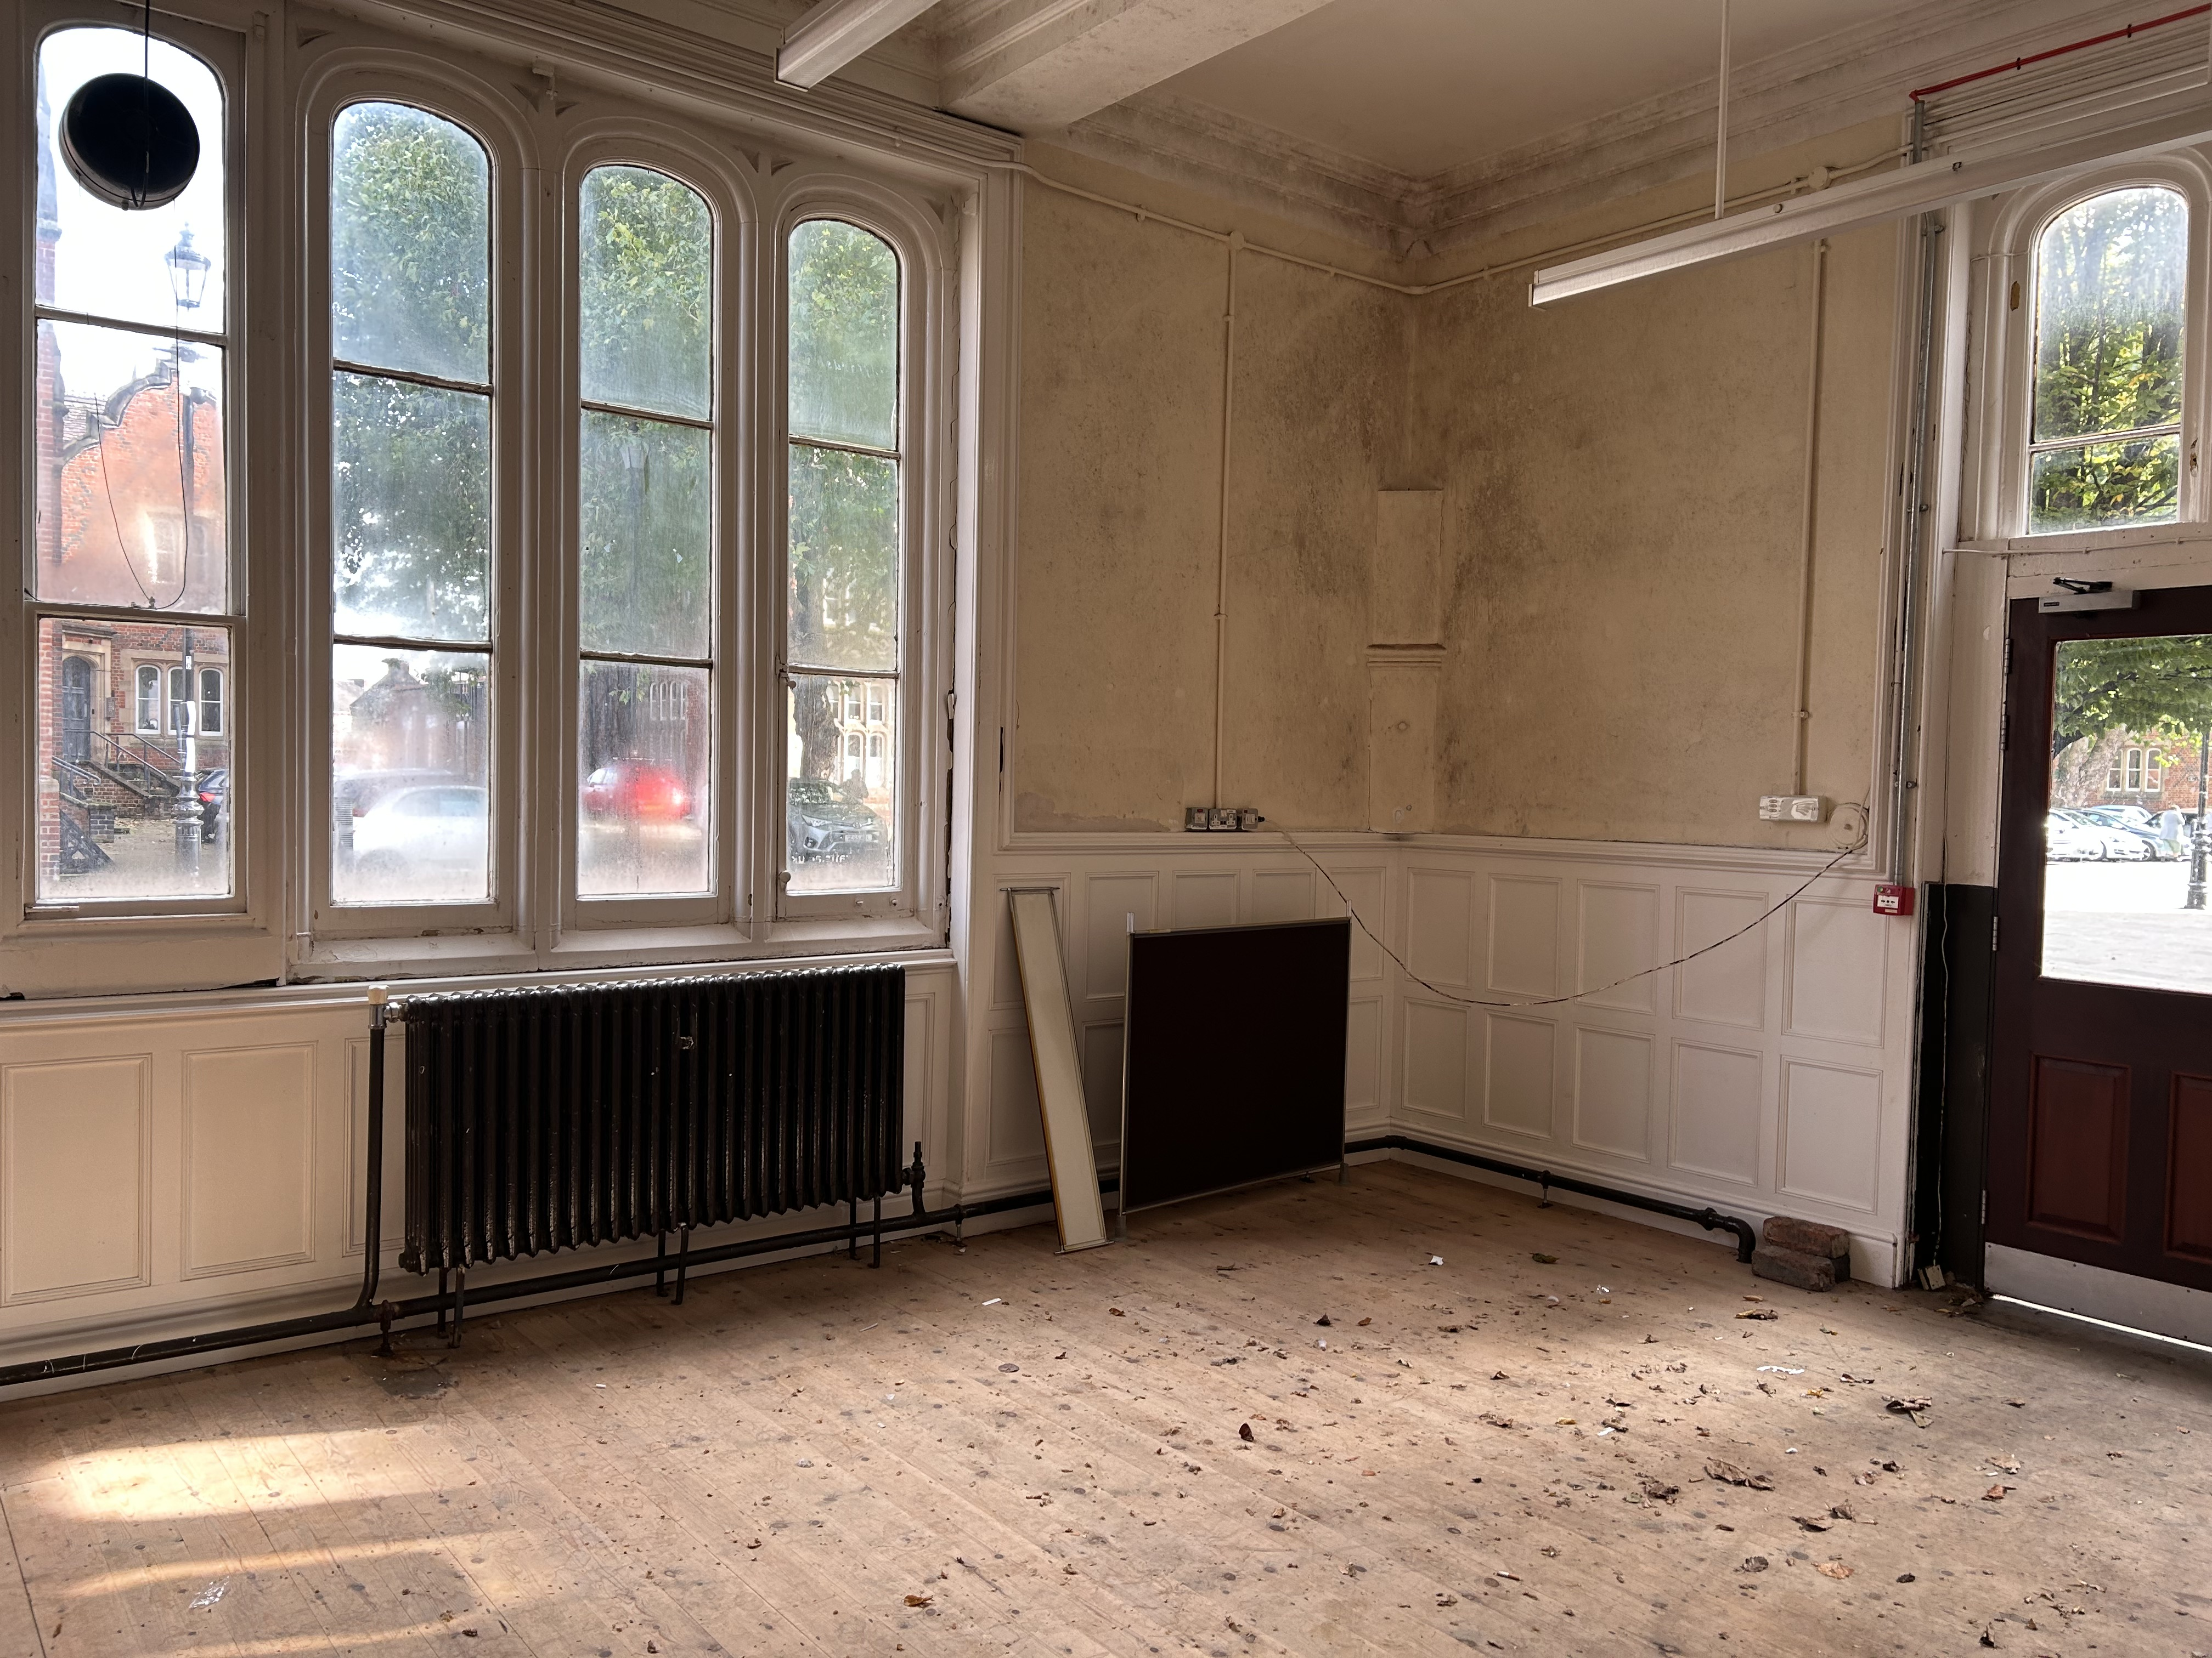 | It is a show where you get to walk through lots of spaces and talk to the actors.
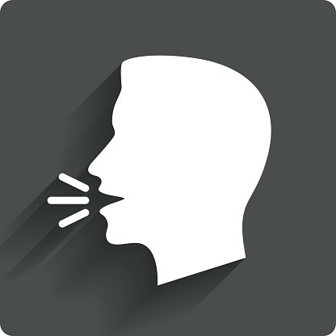 | The performers will talk to the audience during the show.  It is ok at any point in the show to talk to a performer.  It is ok to not reply to a performer if you do not want to.  Tell us if you prefer not to join in, and you’d prefer just to watch.
 | The performance lasts for 1 hour.
 | There will be sound effects in the show

People

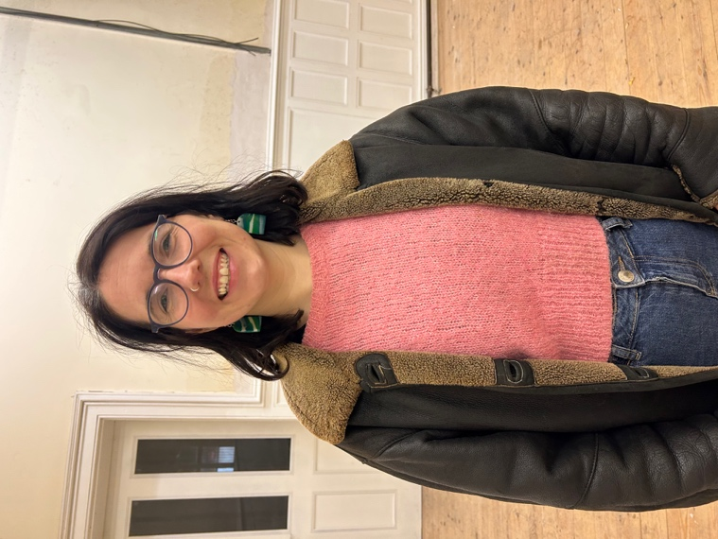 | I am Emily. I am a performer and my character is called Shirley and is the tour guide.  In the show you find out that I am a ghost.
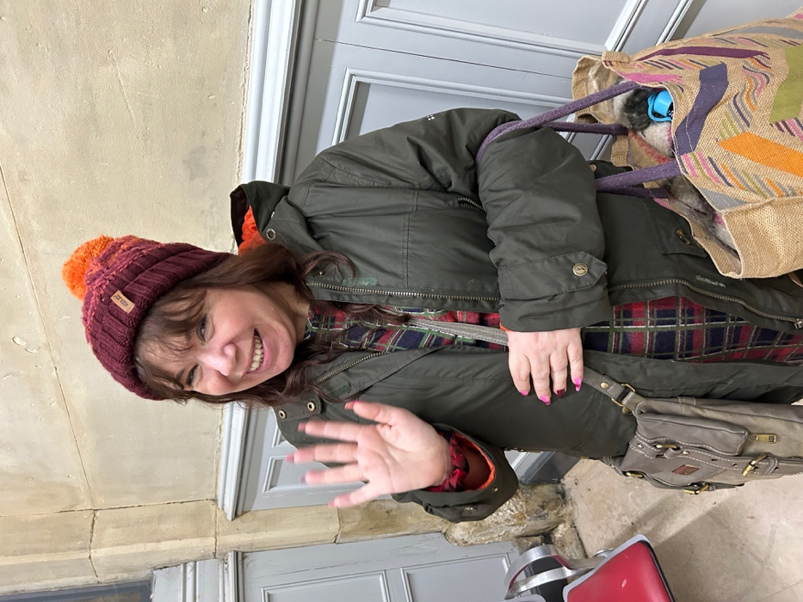 | I am Angela. I will be there to sign Makaton.
 | I am Rebecca. I will help you during the show if you need to leave at any point.
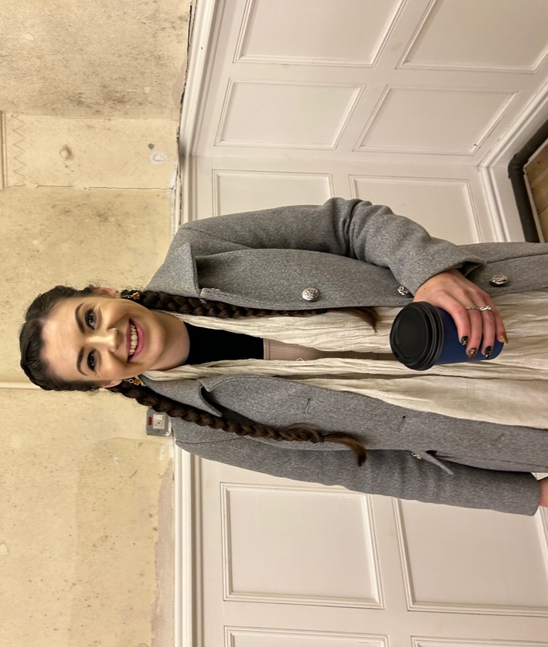 | I am Kath. I am a performer and my character is called Katherine.  In the show you find out that I am a ghost.
I am Ben. I am a performer in the show

In the show you find out that I am a ghost.
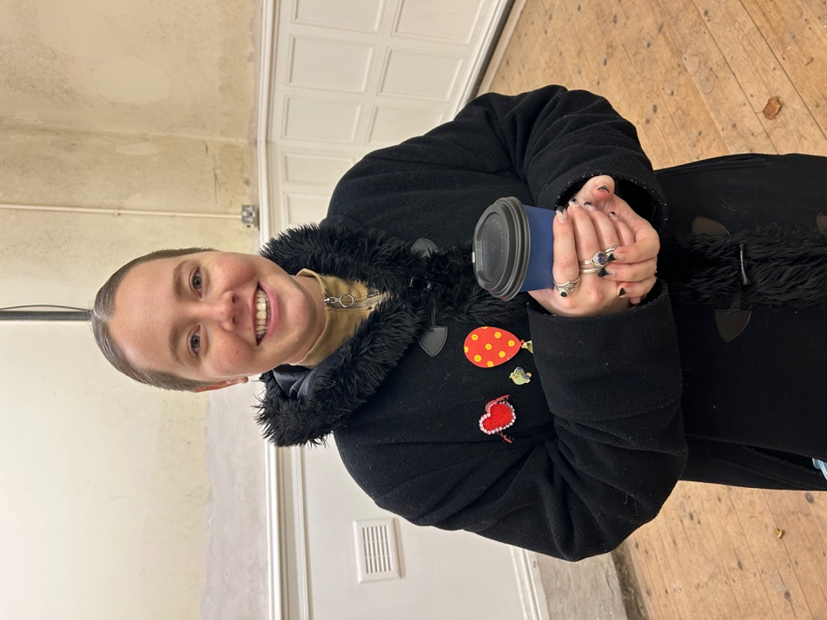 | I am Jess. I am a performer in the shower and my character is called Pearl.  In the show you find out that I am a ghost.
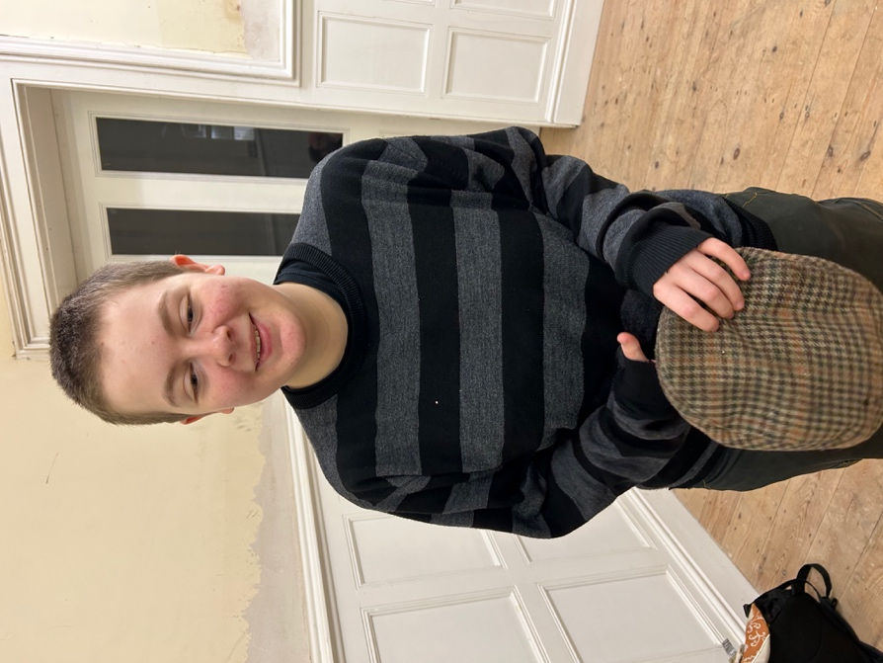 | I am Hayley. I am a performer and I play a Navvy and a ghost of the future.
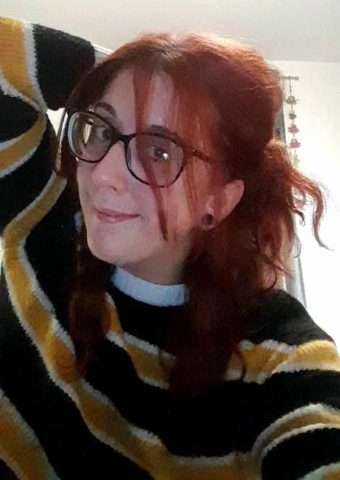 | I am Chloe. I am a performer and I play a Navvy and a ghost of the future.

The Show

We will meet in this space outside the train station

You will meet Ewan, Emily (Shirley) and Kath (Katherine)
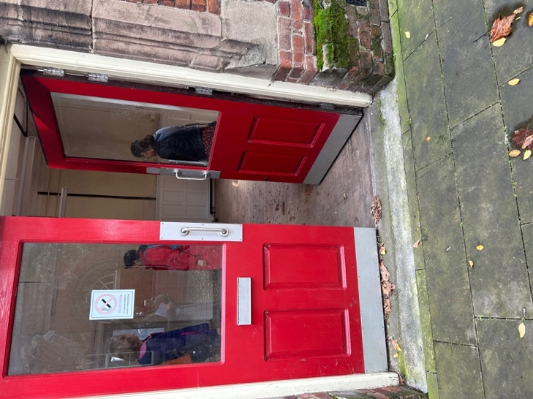 | We will go through this door into the old bookshop
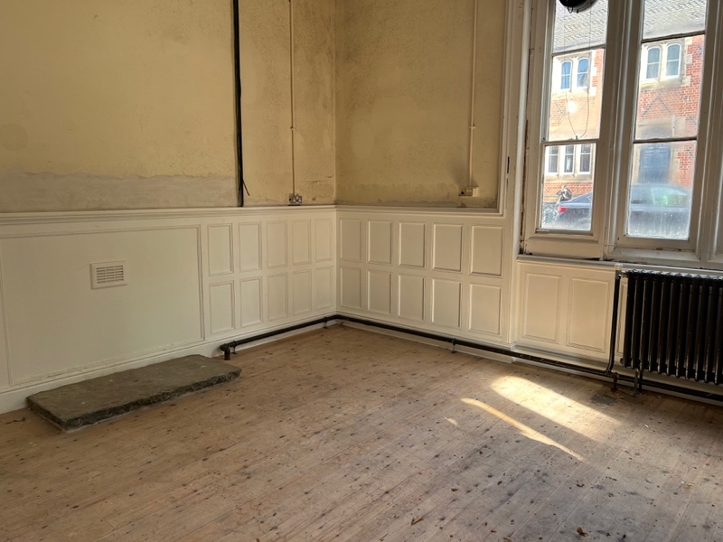 | We will then go into the old bookshop  Here you will meet Ben, Chloe and Hayley
 | We will then go inside the station and through the ticket barrier
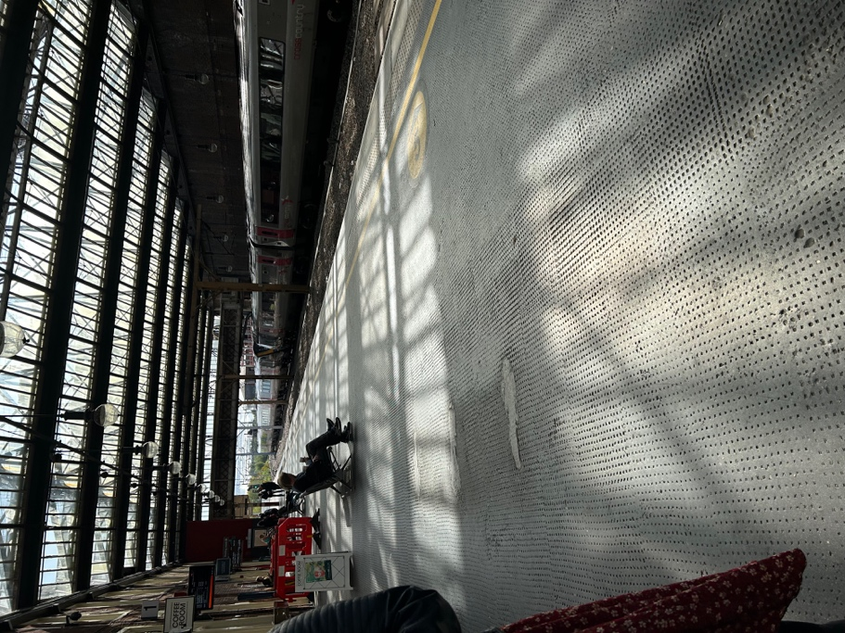 | We will then go onto platform 1
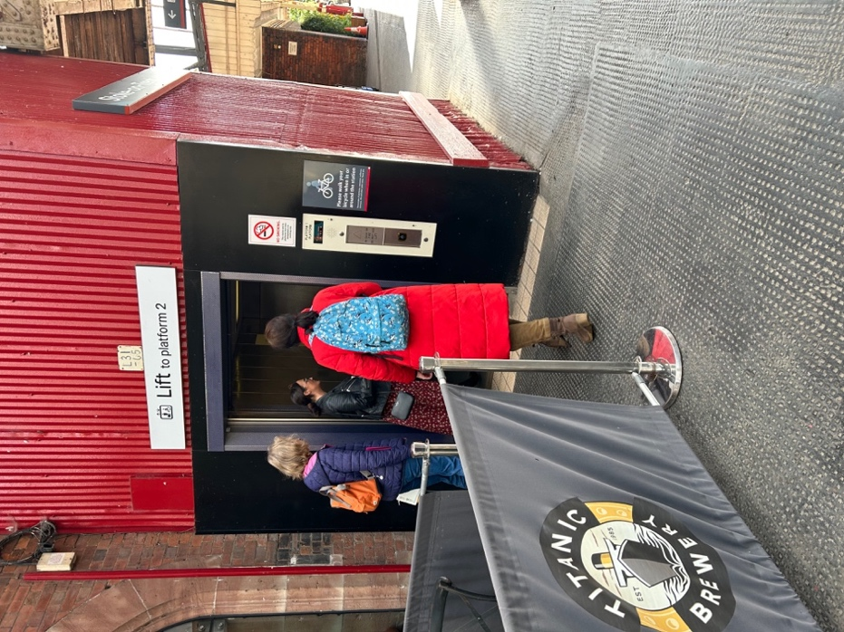 | We will then go into the lift
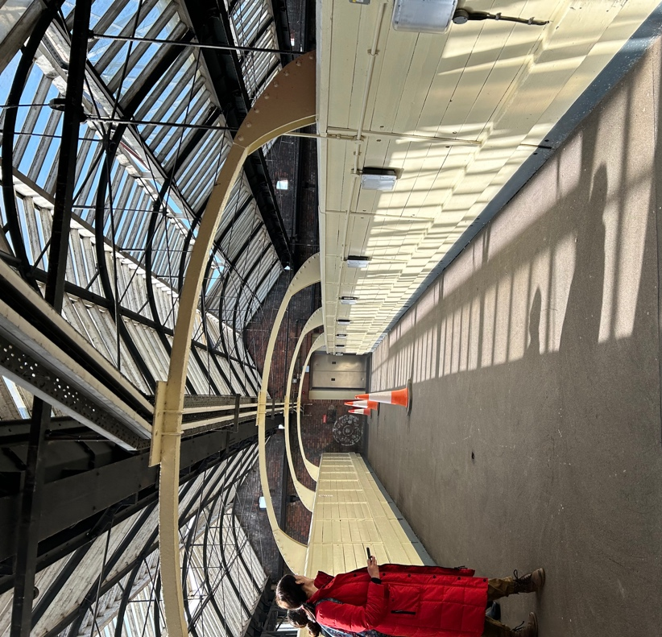 | We will then go on the bridge over the platforms  Here you will see Jess (Pearl)
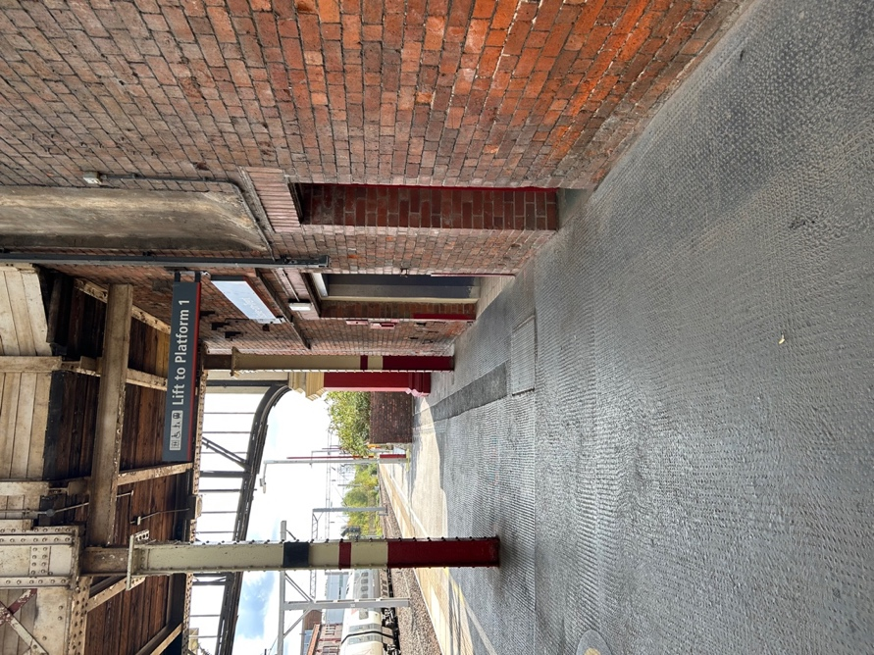 | We will then get into the lift down to platform 2
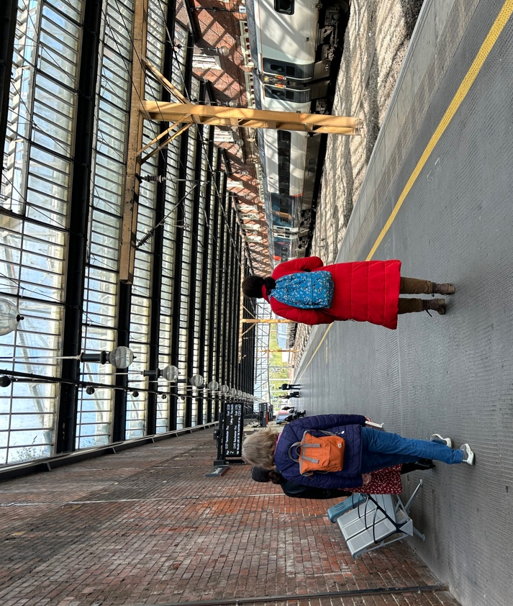  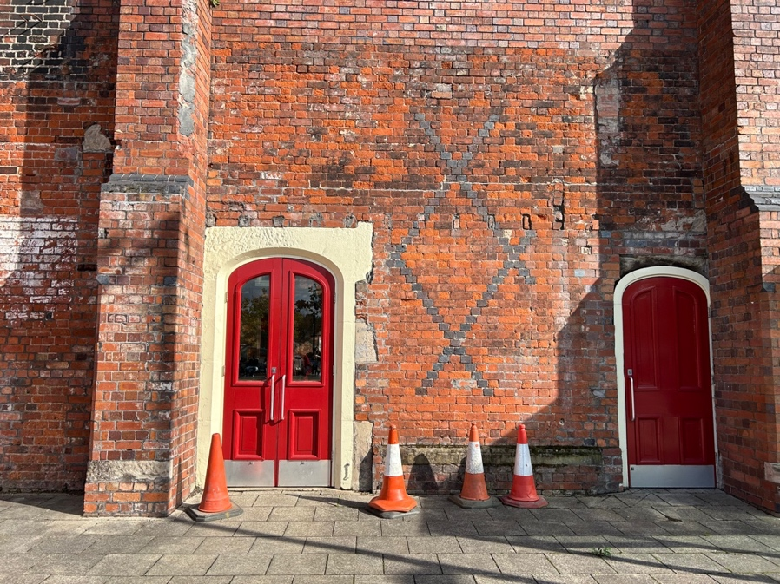 | We will then walk down platform 2  We will exit the station to go outside
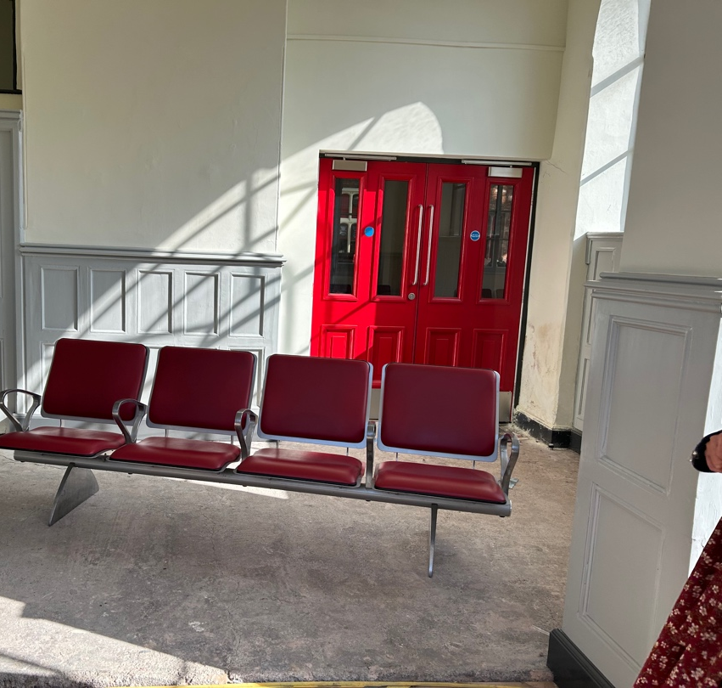 | We will then go back inside and into the old waiting room  Here you will meet Jess (Shirley)
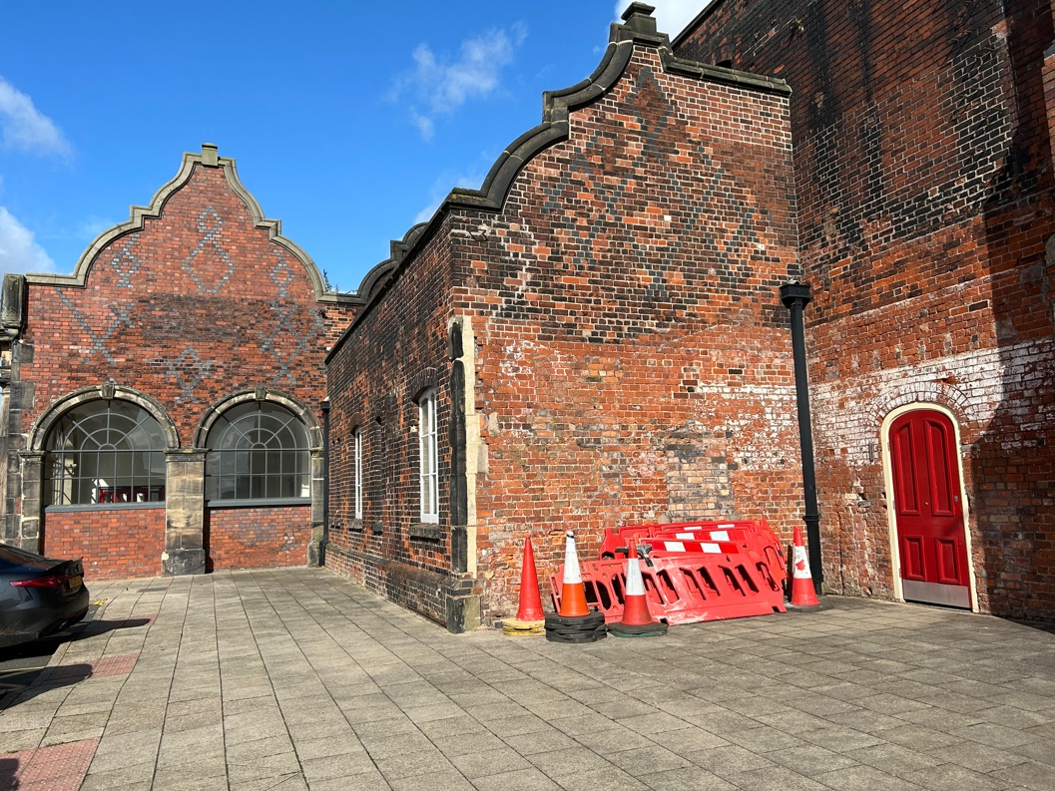 | We then go back outside to this area  We will meet the ghosts of the future  There will be some food and drink at the end.  The end.

