“The Lost Post Office”
Easy Read Visual Story

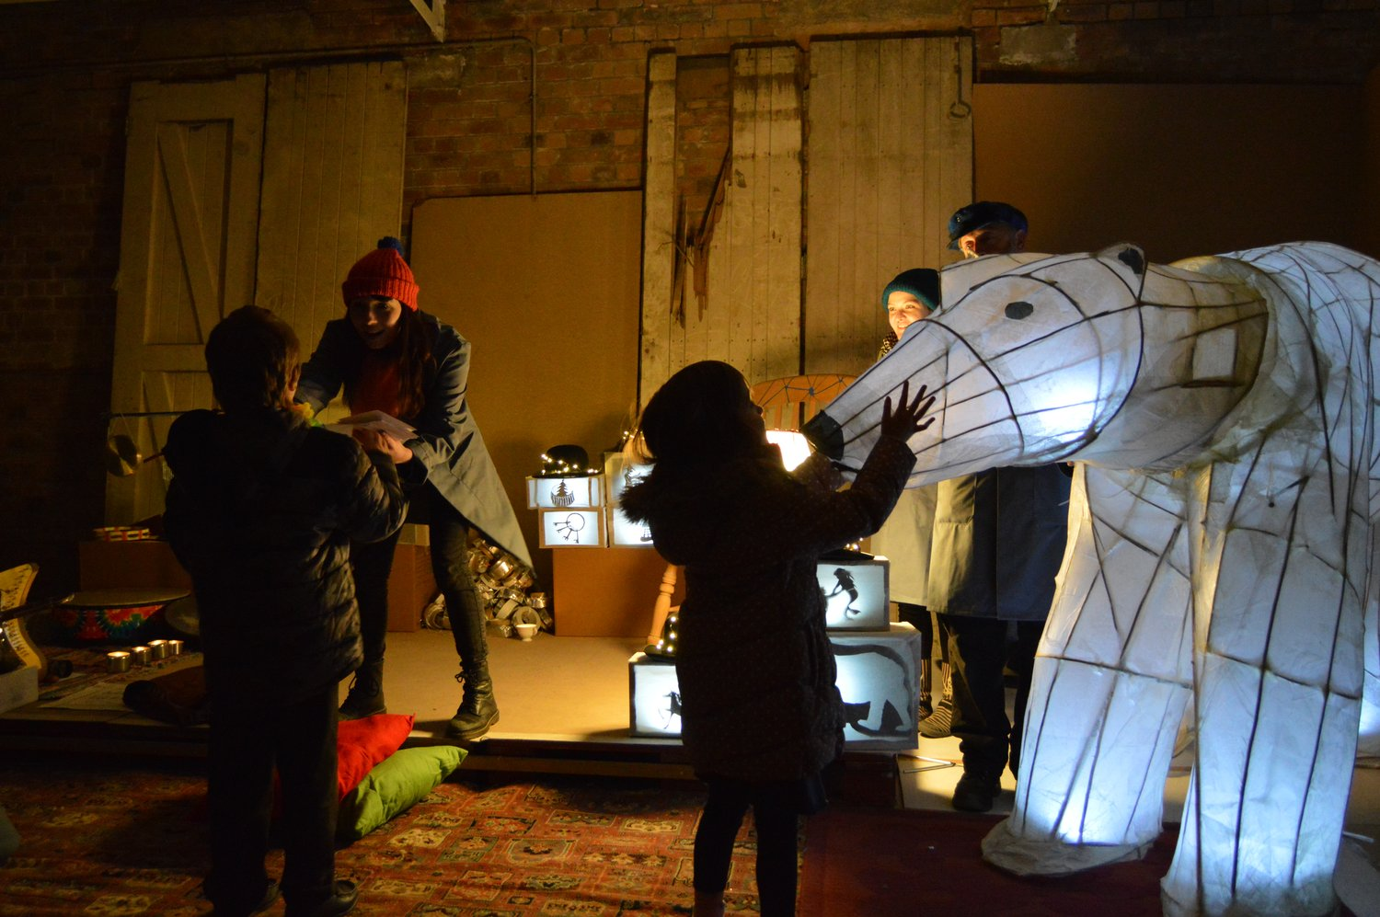

About the Performance

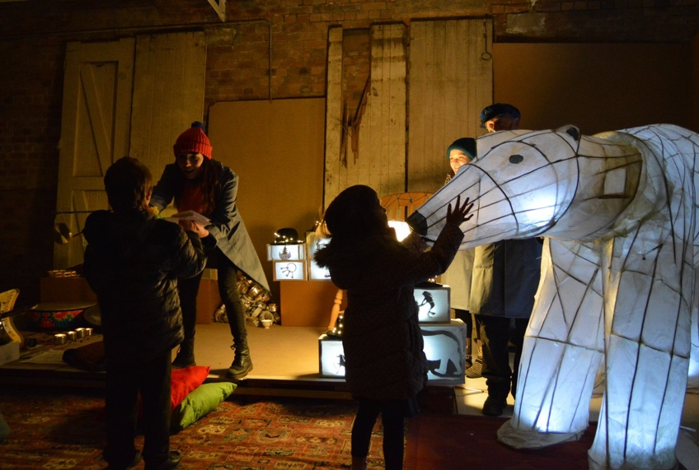 | “The Lost Post Office” is a show by B arts.  The show takes place in the form of a tour.
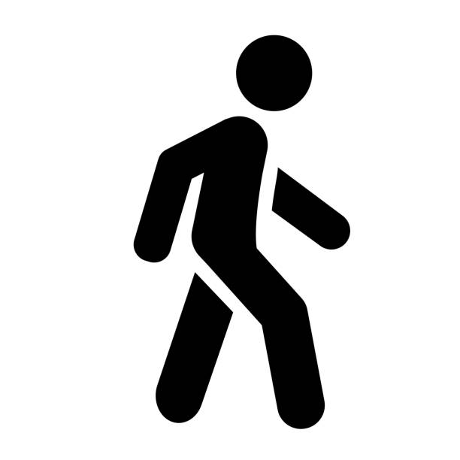 | We will be walking around altogether throughout the show
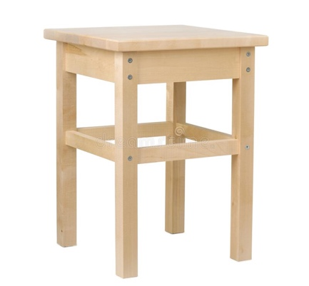 | There will be some seats in each section if you need to sit down.
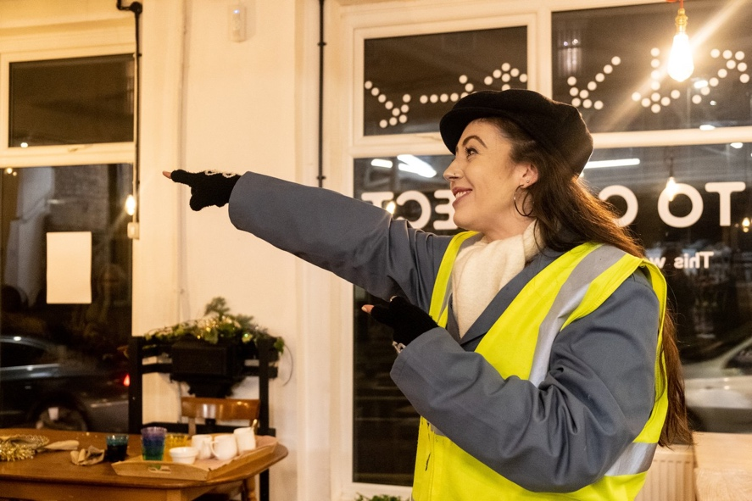 | 17 performers perform in the show “The Lost Post Office”  The performers wear blue overalls, flat caps, scarves and fingerless gloves.  Some performers will wear high visibility jackets at the beginning of the show.
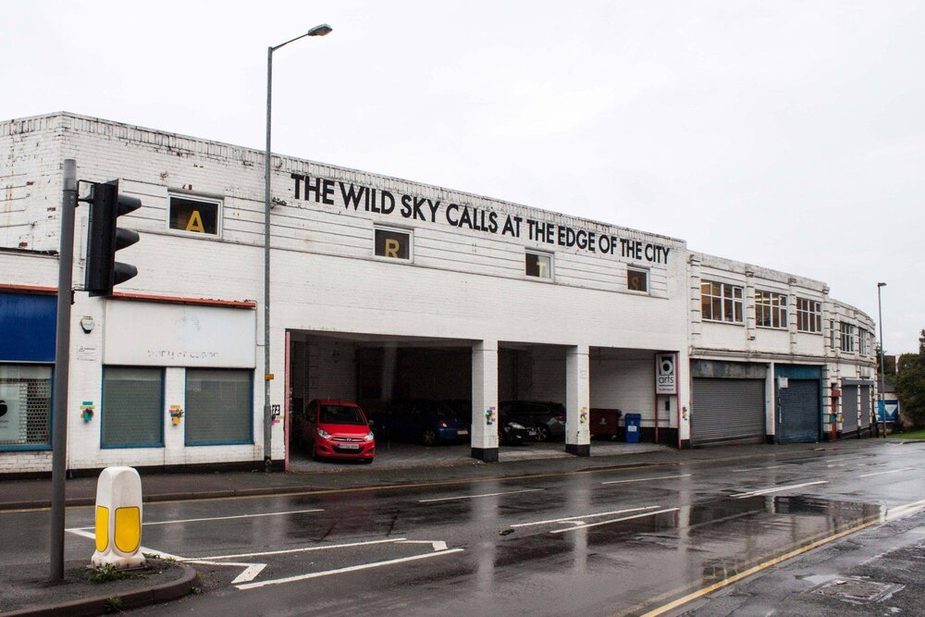 | The show is performed at B arts
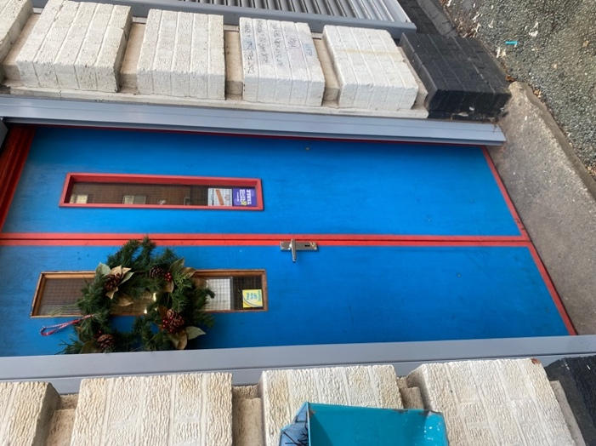 | This is the entrance you will use when coming to watch the show “The Lost Post Office”, at B arts.
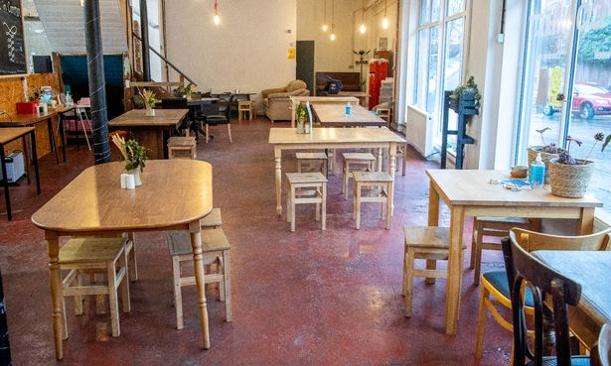 | The audience will meet in the café at B arts, called Bread in Common.
 | The café may be a little bit noisy as some audience members may be enjoying food and drink before the show.
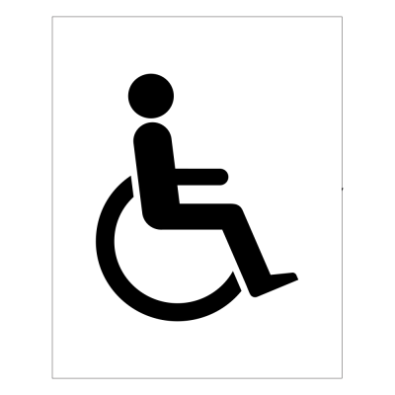 | There is an accessible toilet at the back of the café.
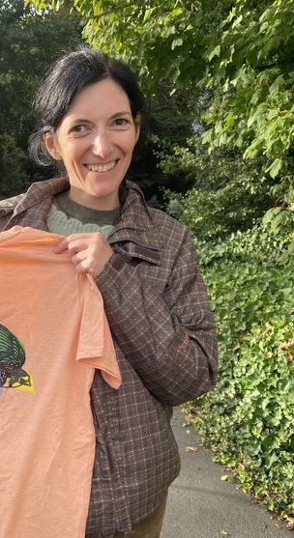 | This is Rebecca.  You can ask her if you need to be somewhere quieter.  She can help.
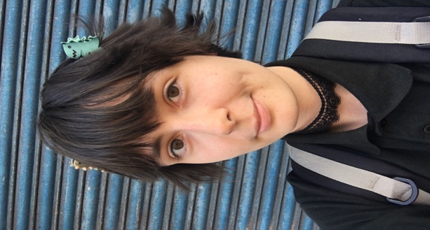  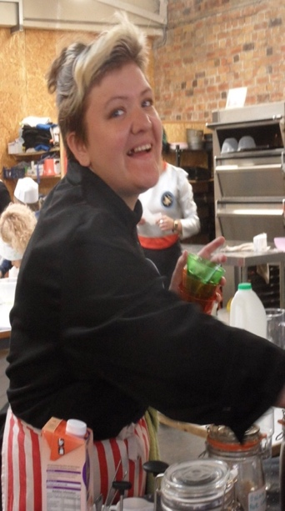 | This is Cher, Shiv, and Alex.  They will welcome you in to the Café space.  They will be able to assist you when in the Café.
 | “The Lost Post Office” is an inclusive show. It is a relaxed and accessible show.
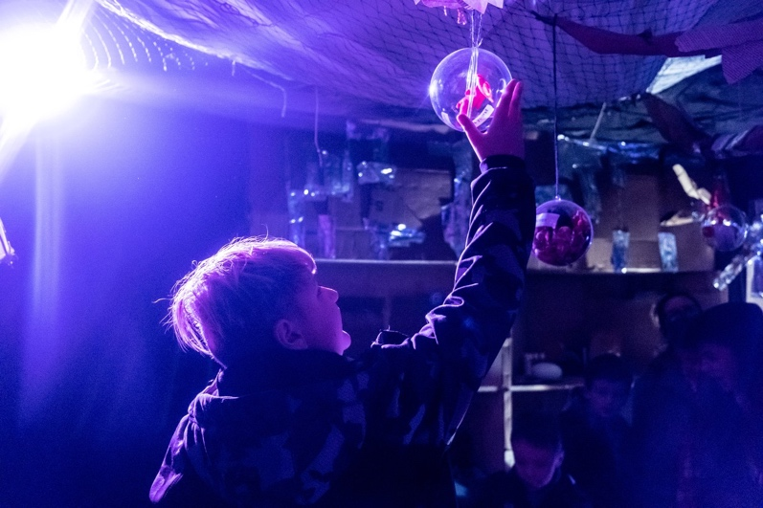 | It is a show where you get to walk through lots of multi-sensory spaces, touch things, hear things, and talk to the actors.
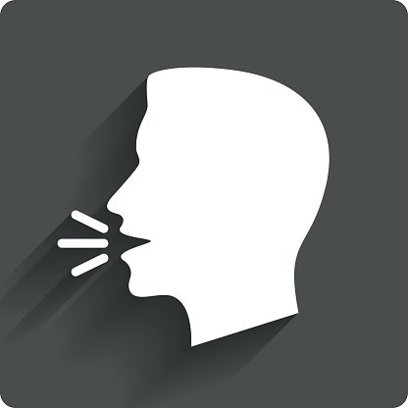 | The performers will talk to the audience during the show.  It is ok at any point in the show to talk to a performer.  It is ok to not reply to a performer if you do not want to.  Tell us if you prefer not to join in, and you’d prefer just to watch.
 | The performance lasts for 1 hour.
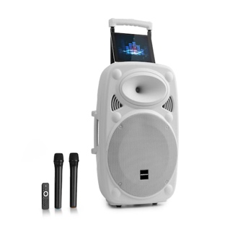 | Please let us know if the music is too loud. We can turn it down.
 | There will be sound effects in the show like water dripping, machine noises, and a boulder breaking open

People

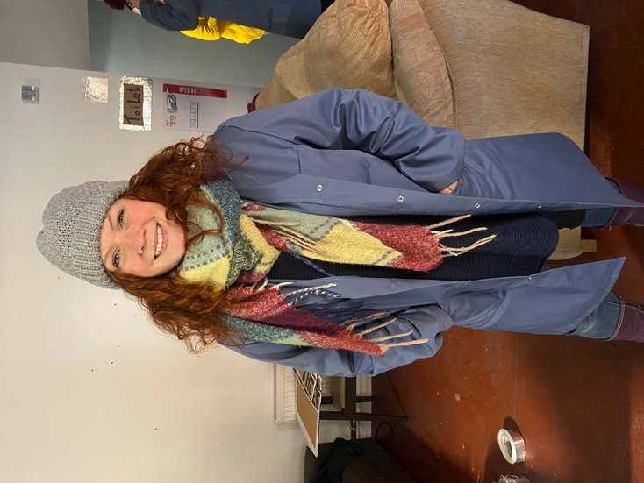 | I am Rachael. I am a performer and musician and I will sing and play songs. I created the music and songs for the show.
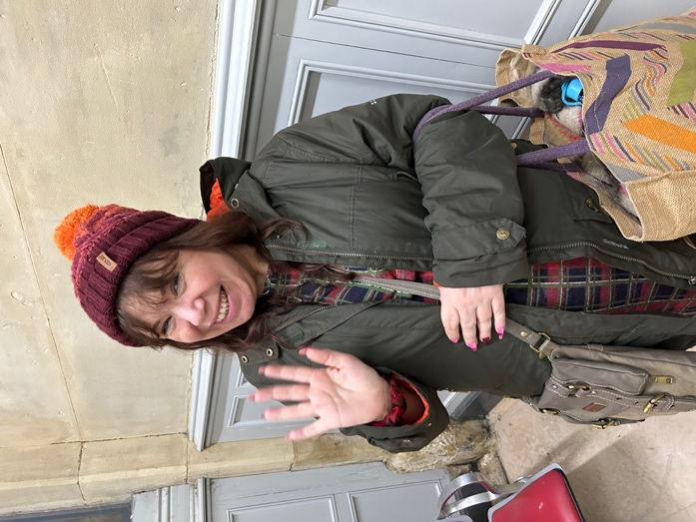 | I am Angela. I will be there to sign Makaton.
 | I am Rebecca. I will help find you a quiet space if you need it
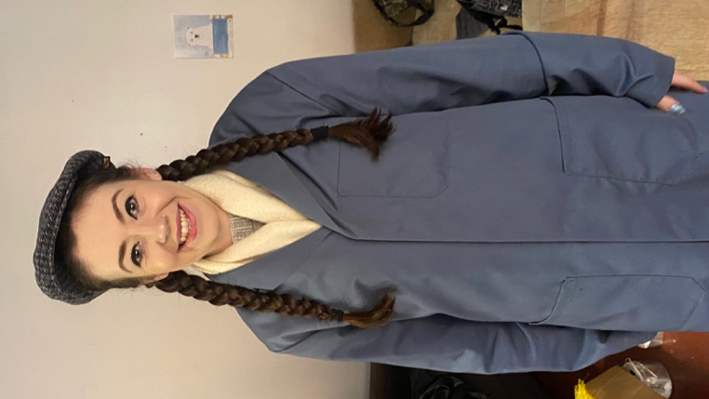 | I am Kath. I am a performer and my character is the tour leader and manager.
 | I am Cynthia. I am a performer and my character is lost post office worker.
 | I am Jess. I am a performer and my character is lost post office worker.
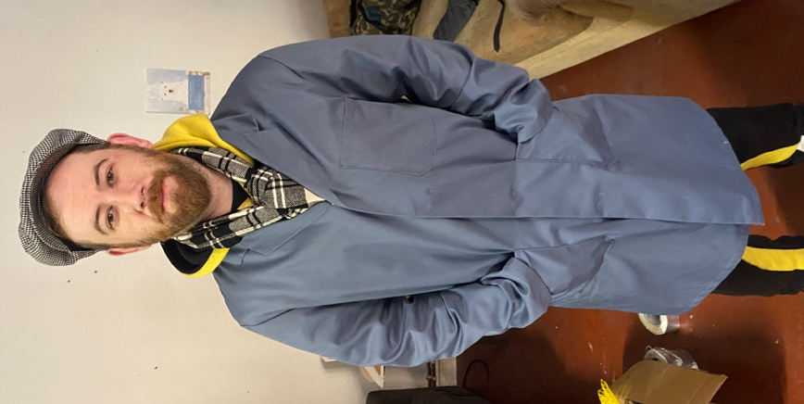 | I am Martin. I am a performer and my character is lost post office worker.
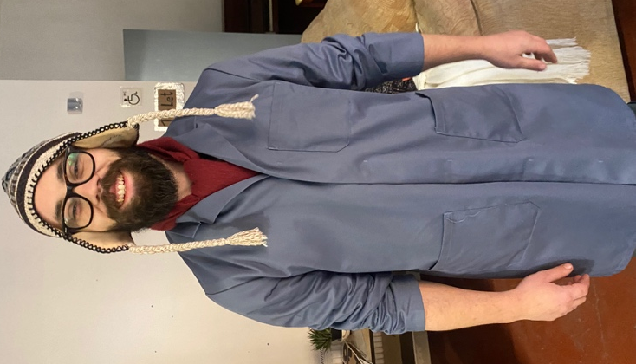 | I am Richard. I am a performer and my character is lost post office worker.
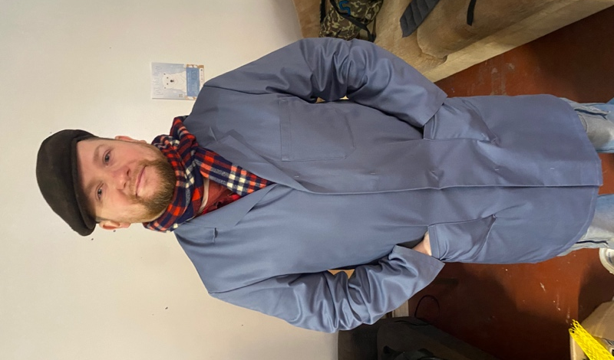 | I am Dan. I am a performer and my character is lost post office worker.
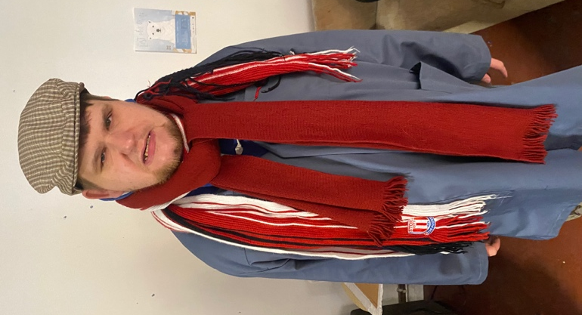 | I am Carl. I am a performer and my character is lost post office worker.
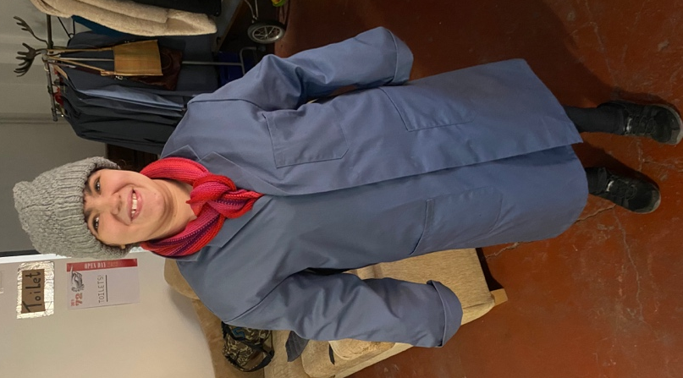 | I am Evie. I am a performer and my character is lost post office worker.
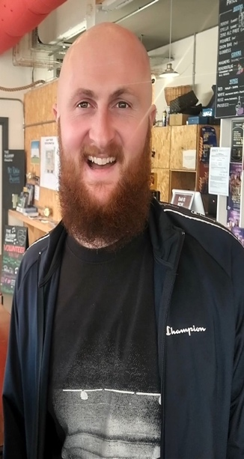 | I am Ryan. I am a performer and my character is lost post office worker. I am also the Duty Manager.
 | I am Artie. I am a performer and my character is lost post office worker.
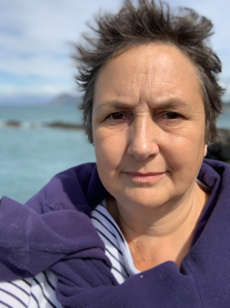 | I am Susan. I am a performer and my character is the Sun.
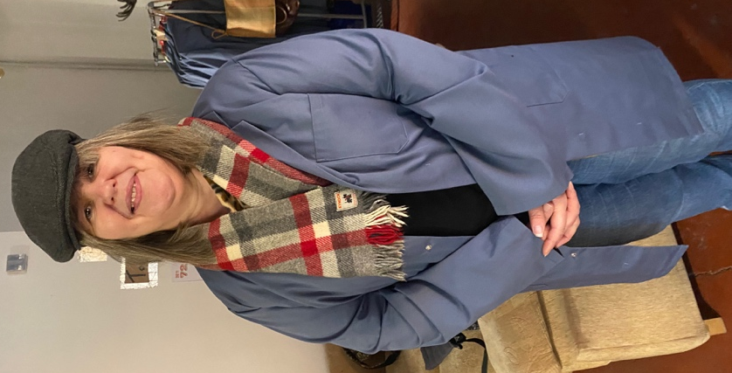 | I am Michaela. I am a performer and my character is lost post office worker.

The Show

The show will start in the café

You will meet Kath, Jess and Richard here
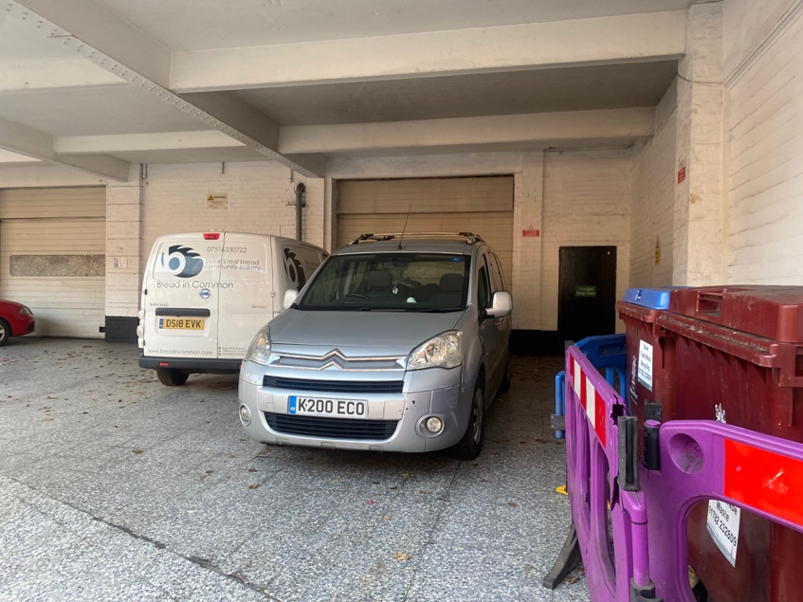 | We will walk to the forecourt.  There will not be any cars parked there on the day.
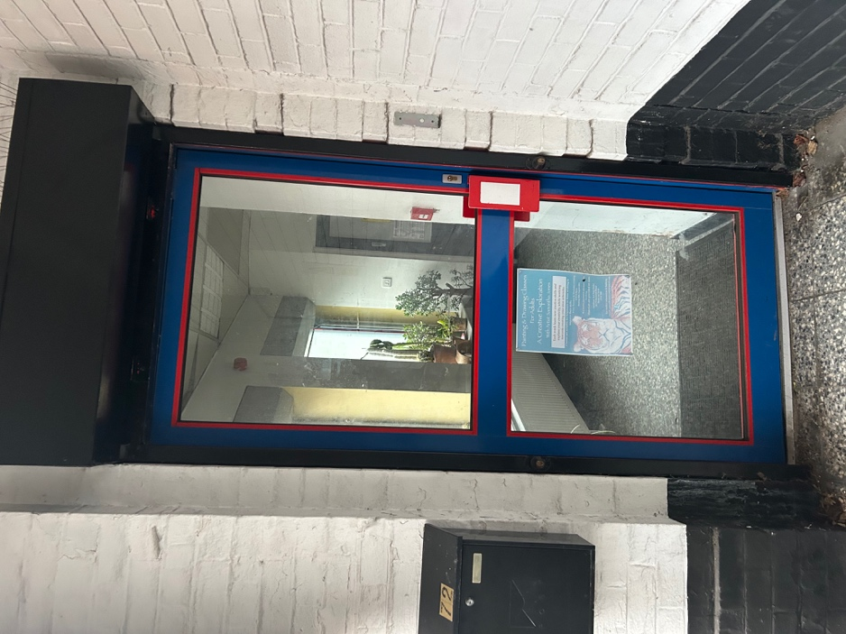 | We will go through the foyer doors and into the foyer
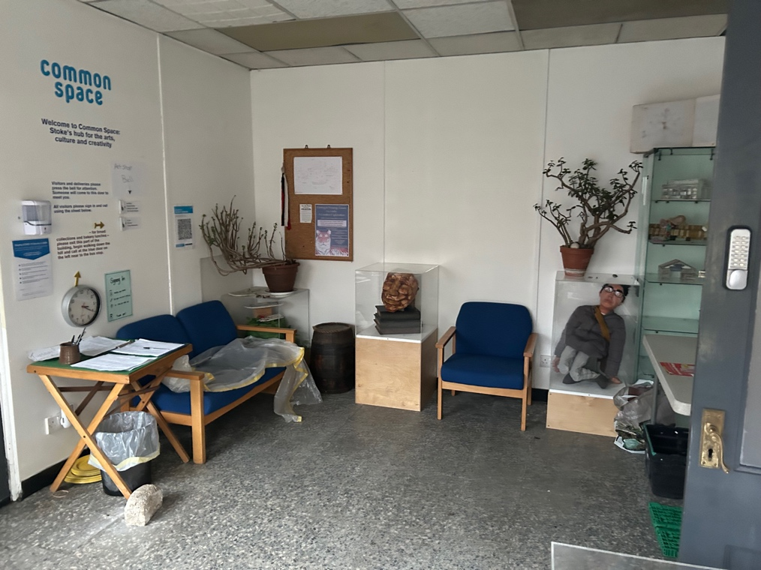 | We will go into the foyer  With Kath, Jess and Richard
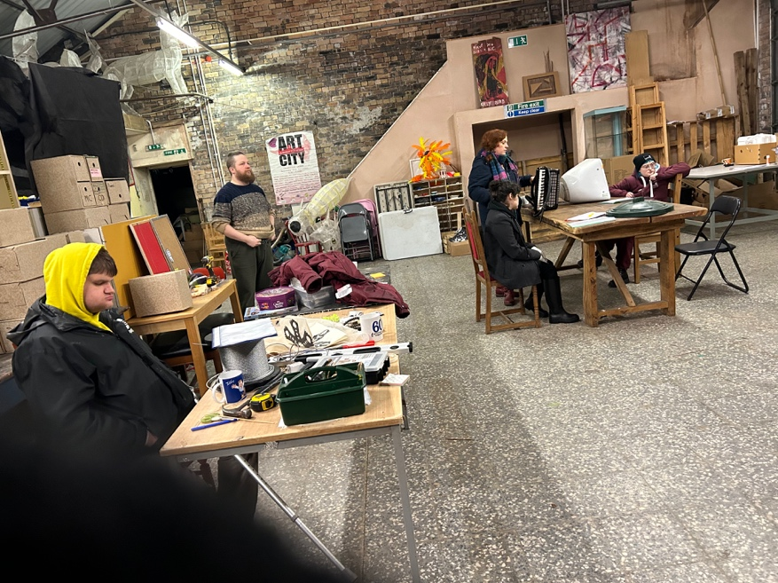 | The Sorting Office of The Lost Post Office will be revealed and in here you will see Richard, Dan, Rachael, Carl, Evie, Peter, Martin, Artie and Micheala.
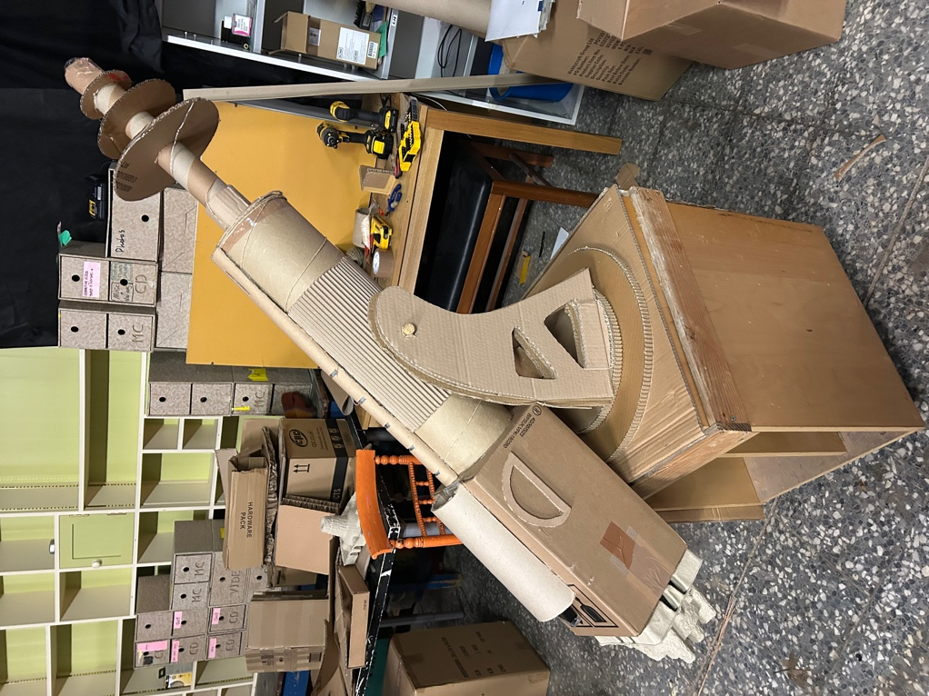 | We will see the Science Department and Shrink Ray Machine
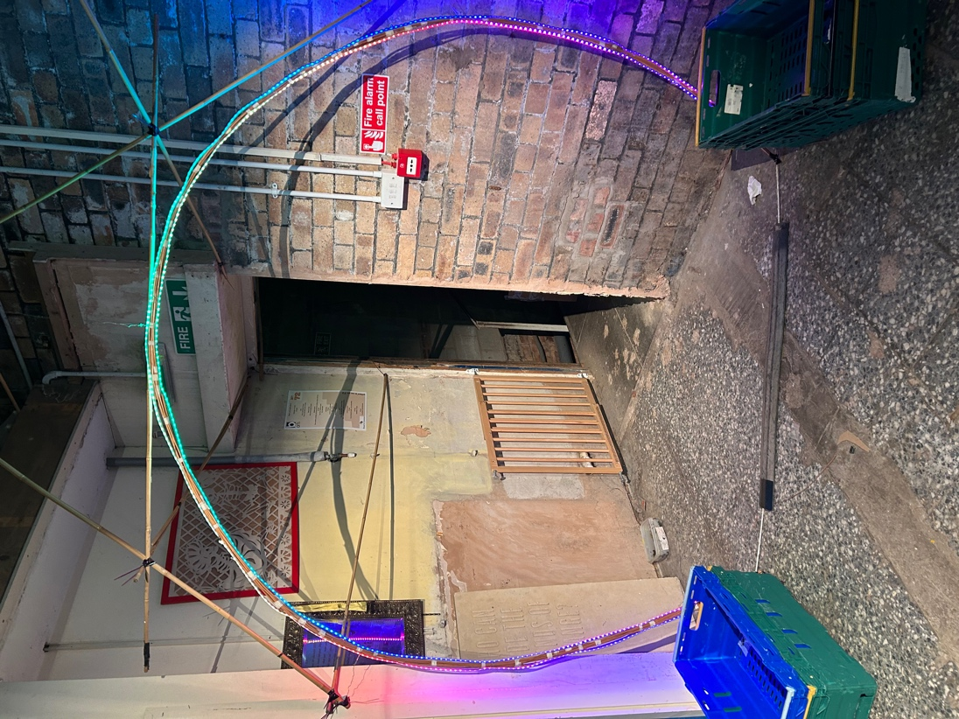 | We will then go into the shrink ray machine
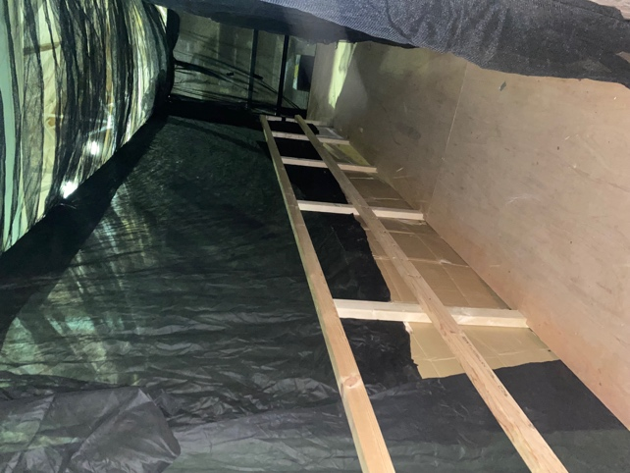 | We will then go through the shrink ray machine (a tunnel down a ramp)
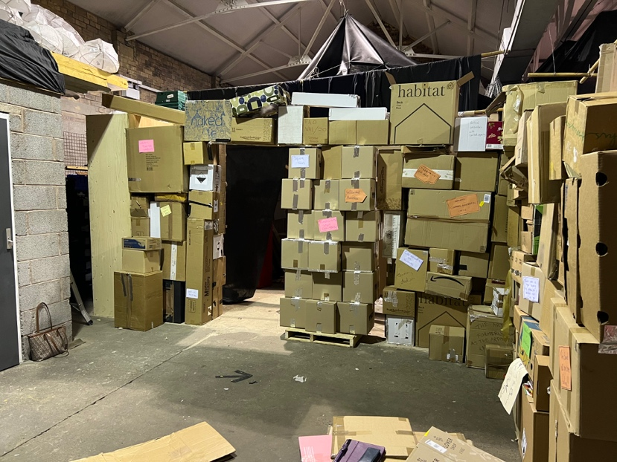 | We will then enter the warehouse and maze of The Lost Post Office where there will be stacks of cardboard boxes
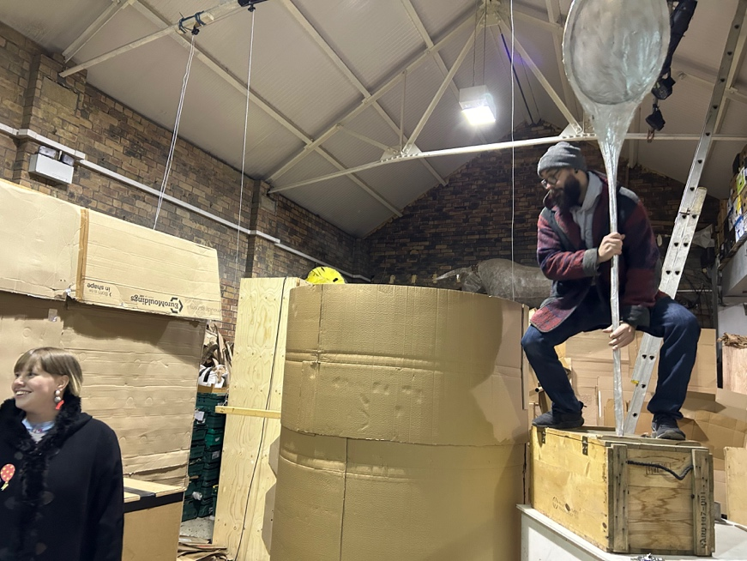 | There will be a giant mug  We will have to gather things into the mug to make a brew to make it move
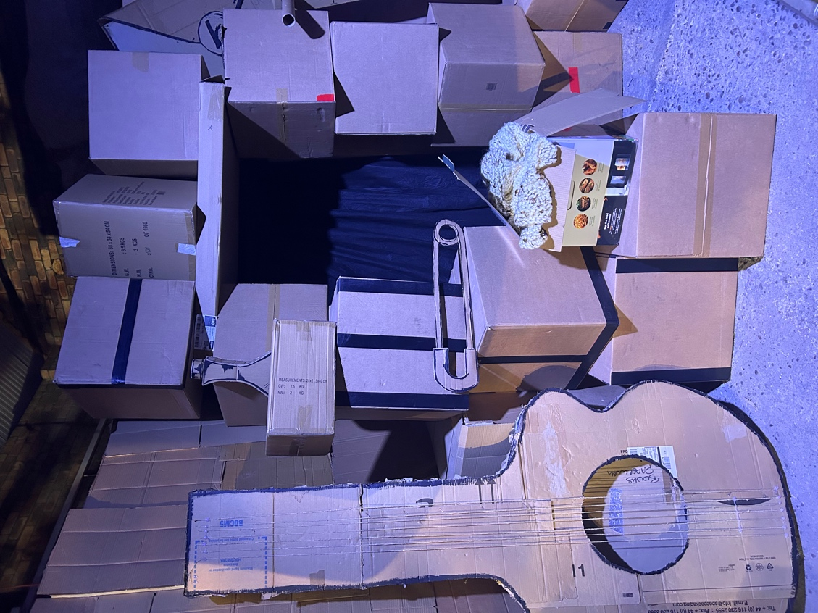 | We will then meet Cynthia
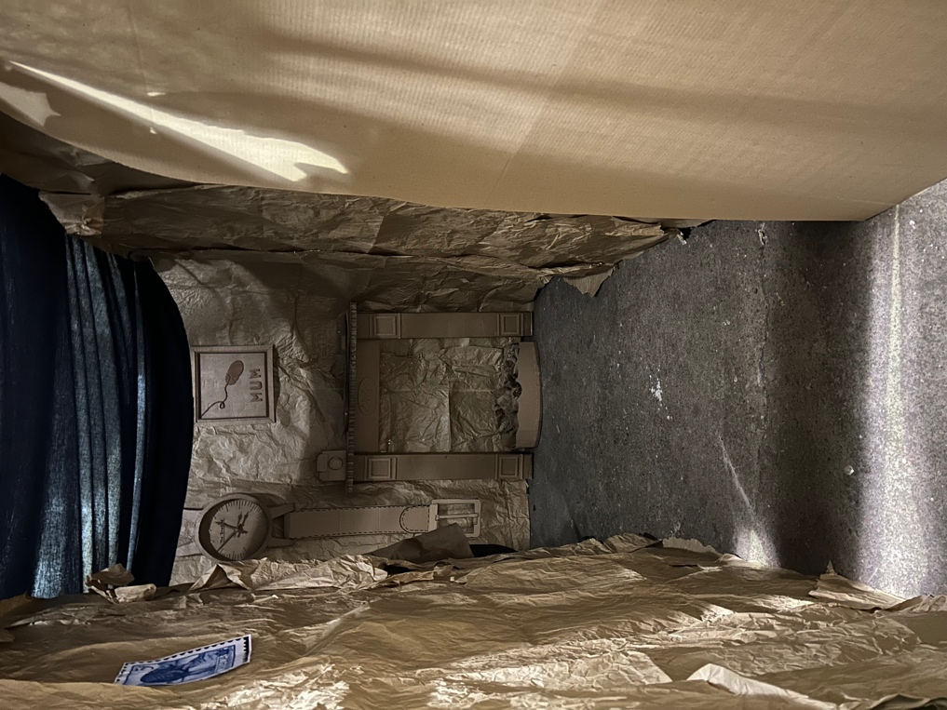 | We will go through the mouse hole
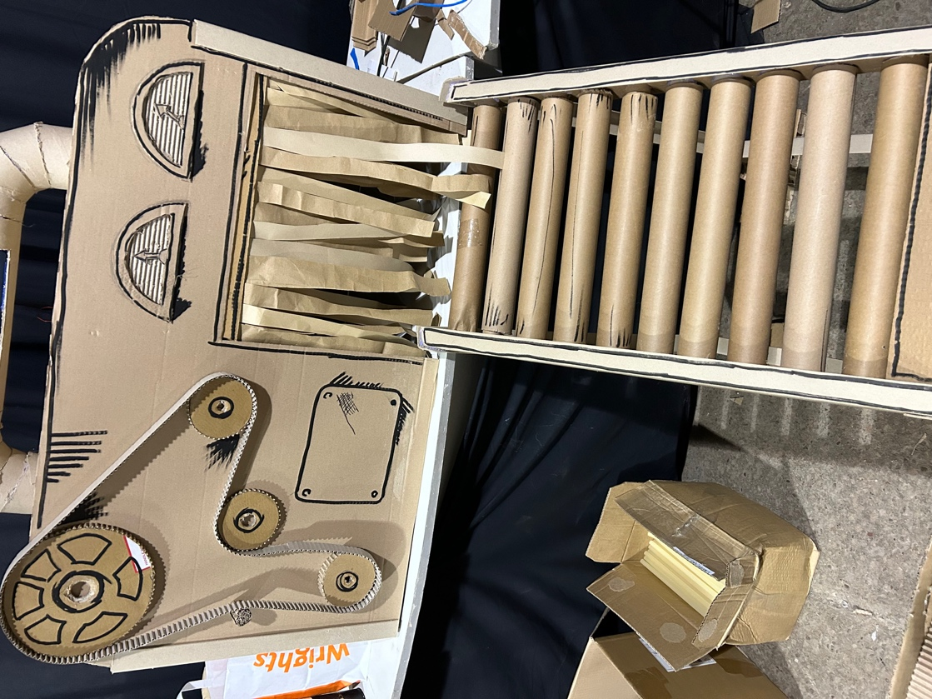 | We will then see the dangerous parcel testing machine
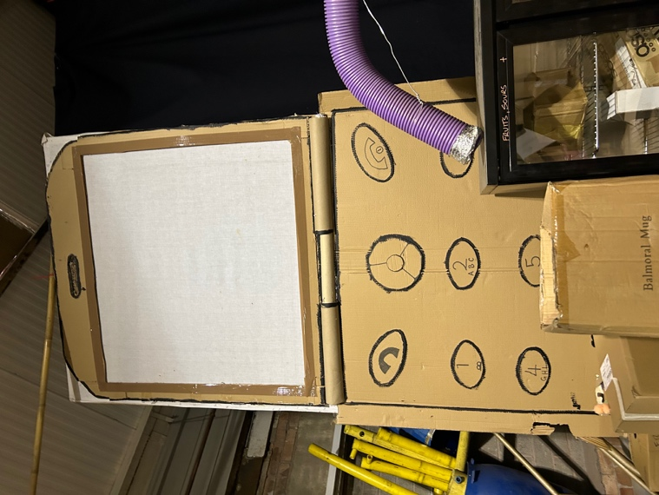 | We we will see Carl on a screen
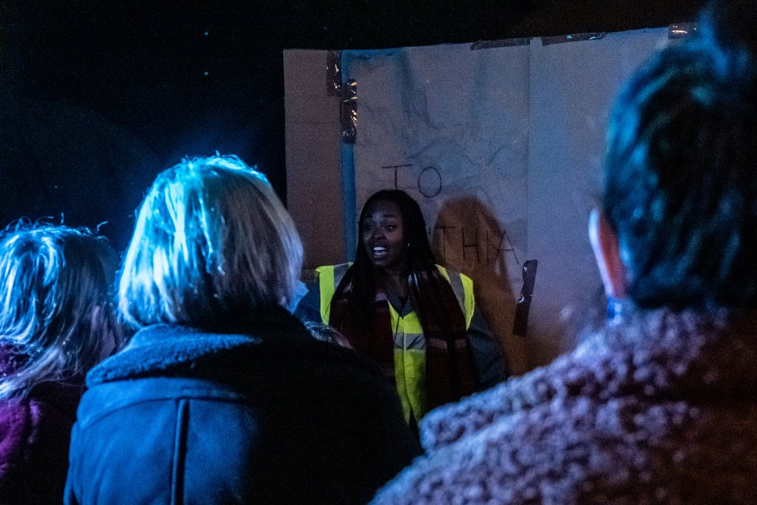 | We will then see a giant parcel addressed to ‘Richard’
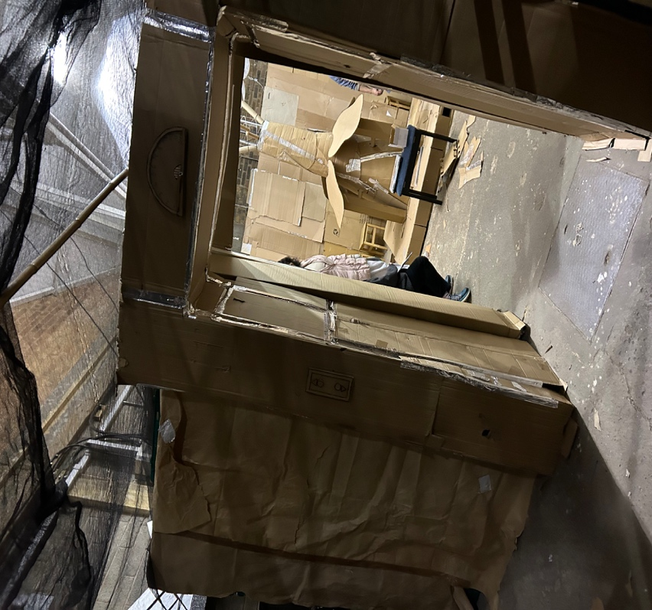 | We will then enter a waiting room for the lift
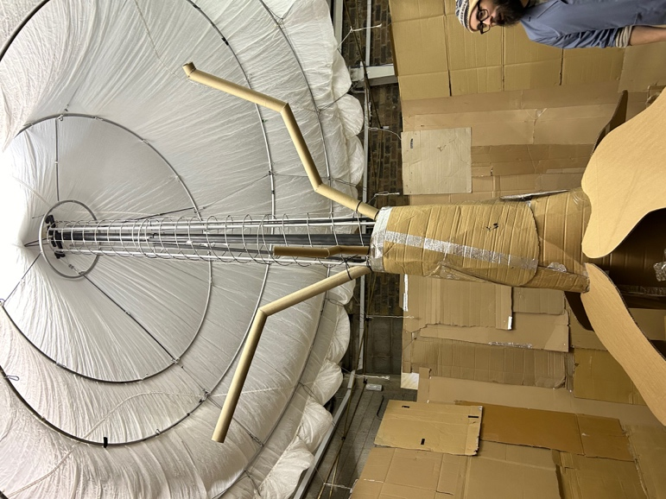 | We will then all go inside the lift  The lift will have buttons all around that you can touch  The lift will move and we will journey to the sun
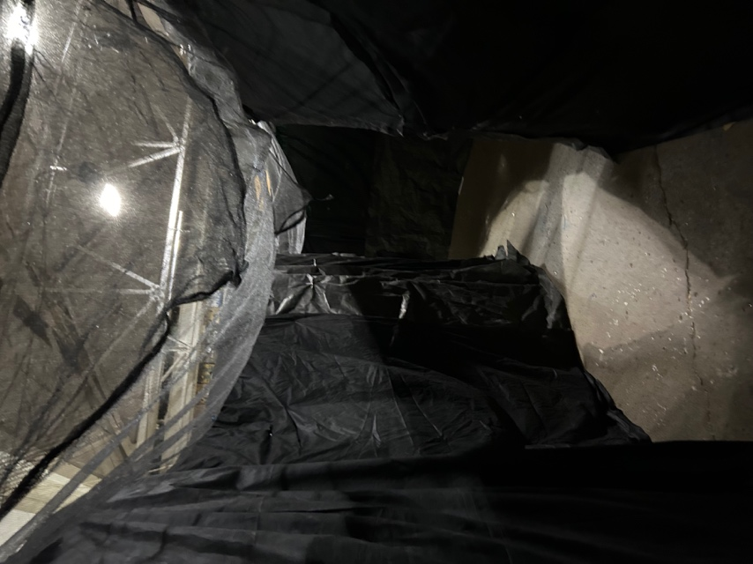 | We will then leave the lift and go into a tunnel
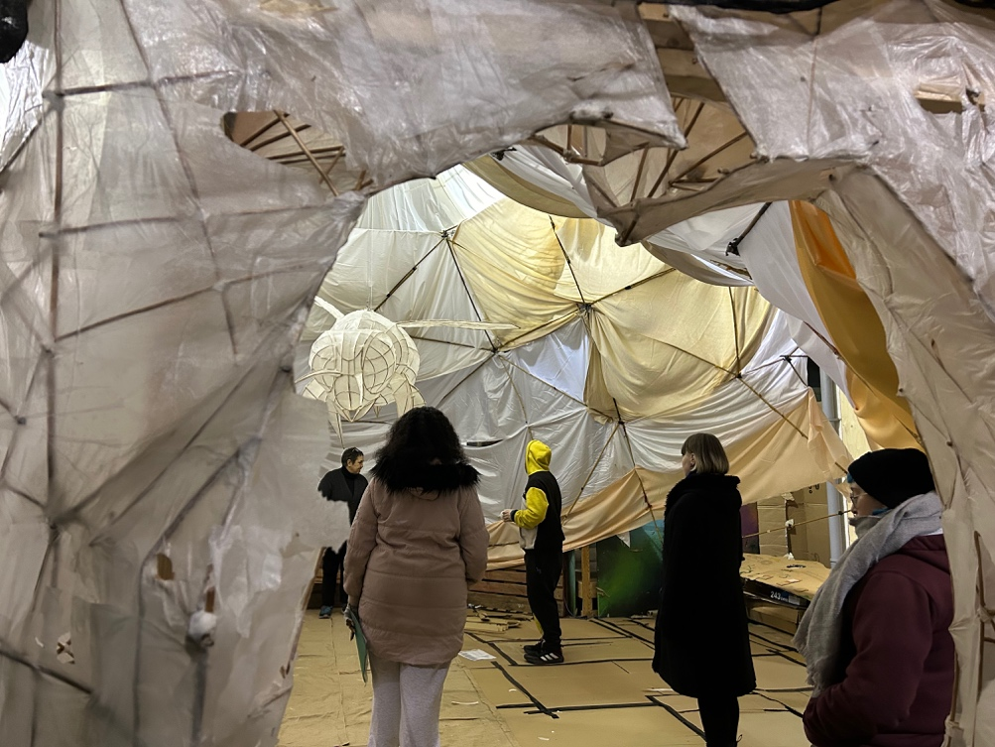 | We will then go into the Hive  We will then meet Susan and we will listen to a story and watch a shadow play
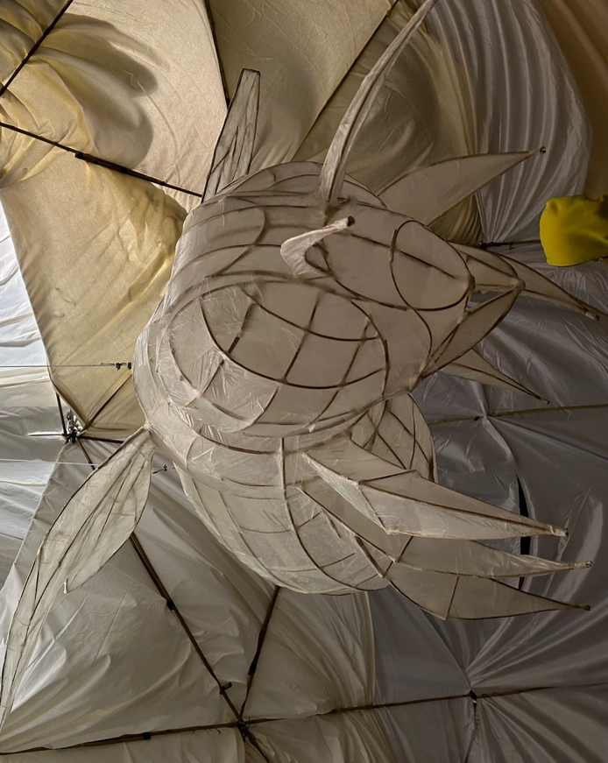 | There will be a giant Bee that will bring us post at the end
Martin will break through and show us the way out.

The End.

